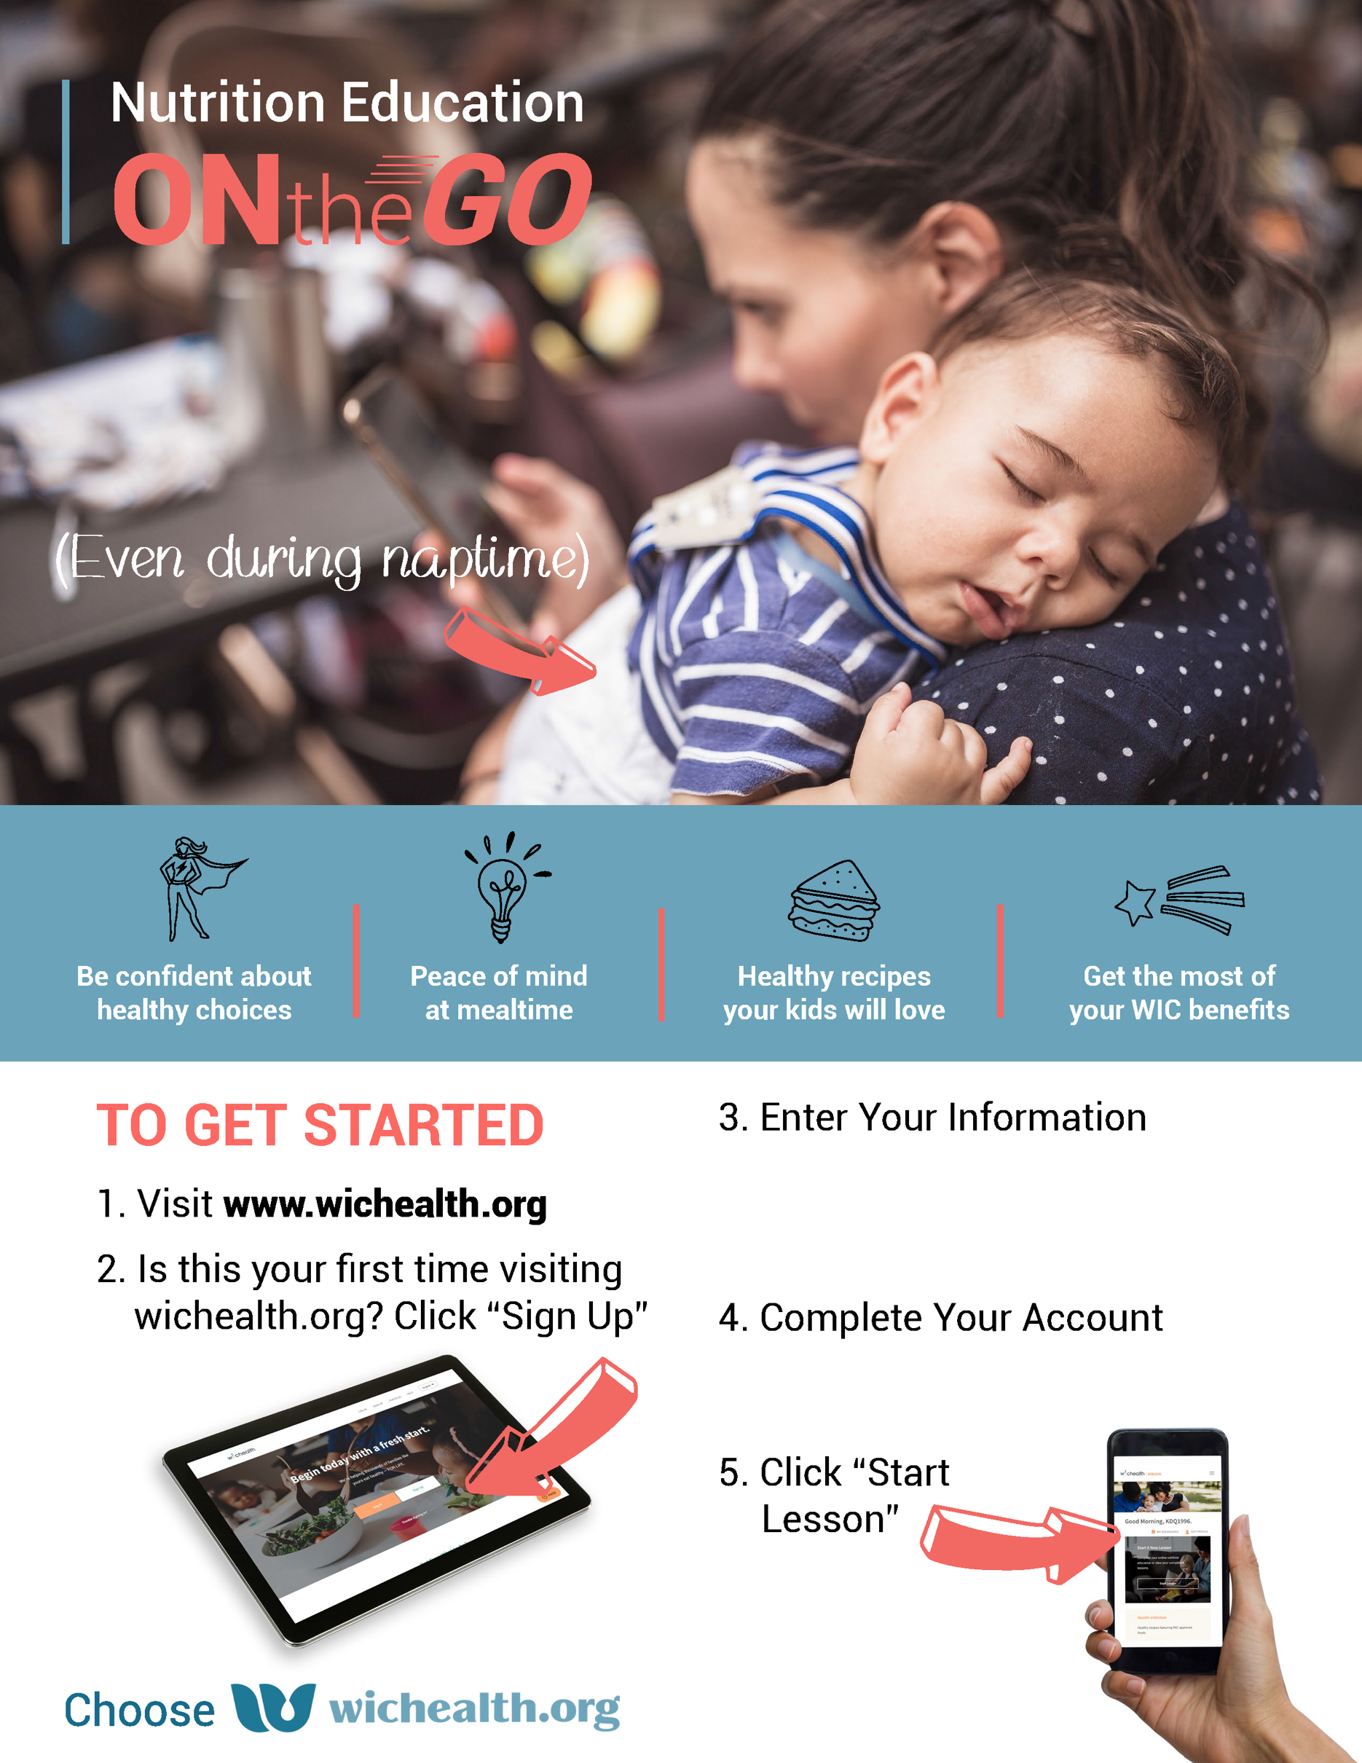
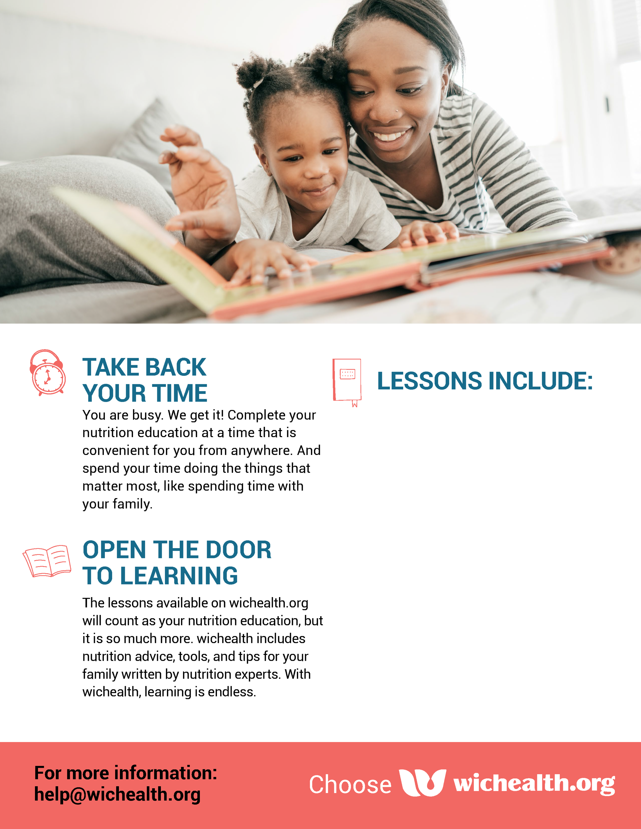
Username:
Password:
Agency:
Clinic:
WIC ID:
- Offer Your Baby the Right Foods as He Grows

- Make Meals and Snacks Simple

- Two Minutes Twice a Day for a Healthy Smile

- Be Healthy with Veggies and Fruits

- Understanding Your Newborn: Sleep, Crying and Cues

- Saving Time with No Cook Meals

